**Name: Puspita Das**

**ID: 20301246**

**Sec: 07**

**Course: CSE421**

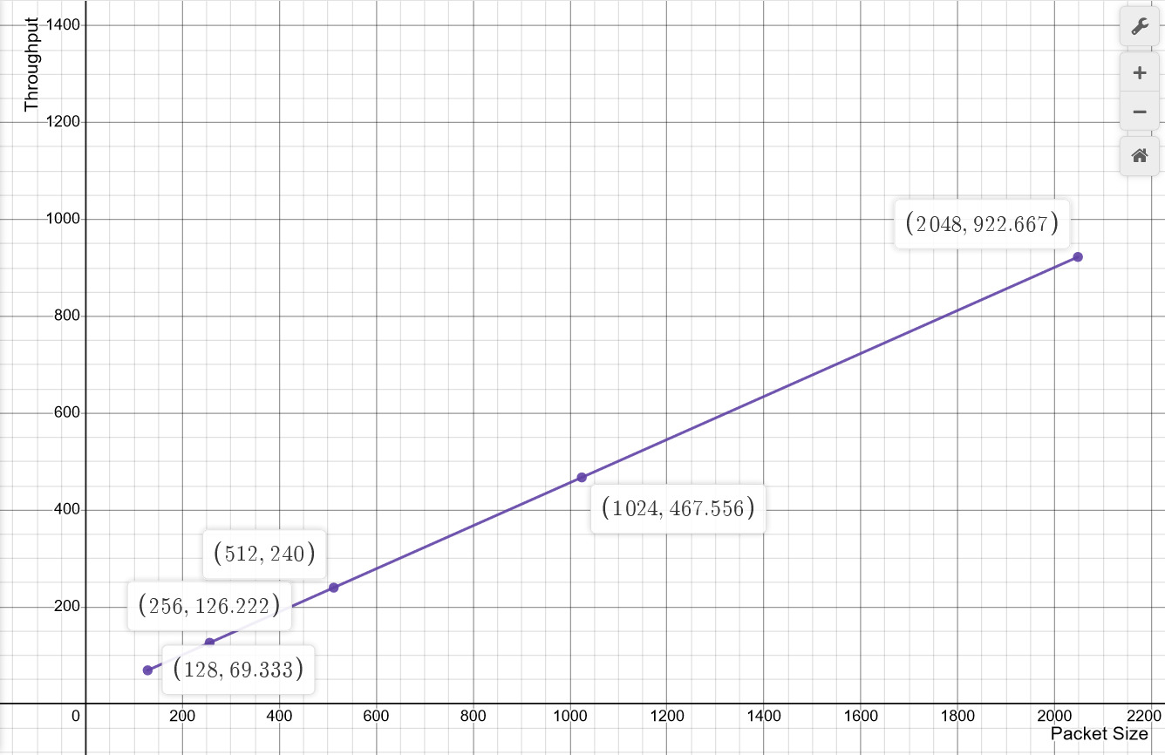

**Figure: throughput vs data size graph**

From the above graph, we can see that Packet size or Data size is in X-axis and Throughput is in Y-axis. Now, whenever the packet size is increasing throughput is also increasing as if packet size increases, then the amount of data that passes through the network also increases so both are proportional to each other.